Brian Faure

RUID:150003563

NetID:bdf39

Programming Methodology II

Homework #2

Problem #1

🡪 See the code in Problem1.cpp

🡪 For N=10, the following was the terminal output…

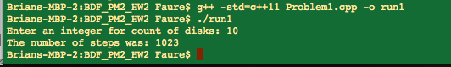

🡪 By guessing and checking I was able to find that my program/computer was able to calculate the answer of the problem up to around 31 discs. Anywhere beyond 31 discs took several minutes to complete. By iteratively calling the solveTowers function and inputting the values 1 through 31, I got the following terminal output…

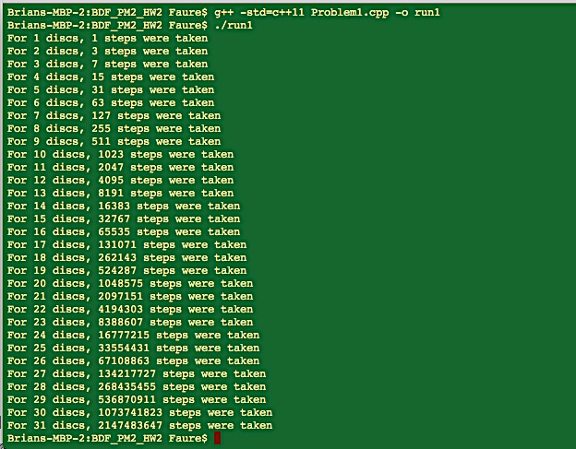

🡪 Loading this data into MATLAB, I was able to create the following graph…

